**November newsletter**

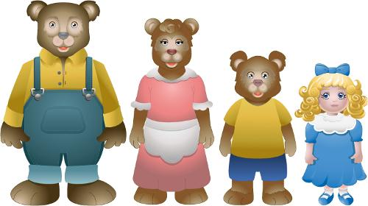

Dear parents,

Welcome back after Halloween break!

We have come a long way since your child’s first day in Nursery. Your children are now enjoying a full session until 1:30pm/2.00pm.

We had a varied and successful October with a visit from Jump Jiggle and Jive, Blackberry farm making our own soup, dressing up for Halloween and much more.

We had a hugely successful fund raising day before the mid term generating £820 to help our much needed school funds. THANK YOU !!!! I had hoped to offer a fantastic programme of visits to other parks and forests in the local area to continue to give our children a rich experience of the outdoors- unfortunately the funding applications that I submitted were unsuccessful due to the huge demand from schools for alternative means of funding. I still hope to offer this programme through self -funding and I am also investigating alternative means of raising the much needed cash to facilitate this kind of work…..so watch this space!

Over the mid term we have had our long awaited play equipment installed for the children. This climbing and balancing apparatus helps to develop physical skills, confidence and problem solving. Come and have a look!

Book fair arrives next week and this is an opportunity for you to purchase some books for your child. You can have a browse and purchase daily from 1.30-2.15pm on Tuesday , Wednesday and Thursday. This fits perfectly with our topic of the month which is fairy tales and traditional stories. Don’t forget our dress up as a character from a book day on 13th November- bring your book along too so we can have a read.

**\*Do you know of any child that is due to come to nursery next year? Please encourage them to contact us so we can invite them to our open day on the 10th December.**

**During November will be concentrating on;**

**Theme: Children’s traditional stories and Fairy tales**

* Exploring children’s stories – identifying the main characters and retelling the stories in our own words.
* Sequencing stories, talking about what happens at the start and the end.
* Making up our own endings to well known stories.
* Dressing up in character.
* Role playing our favourite characters from stories.
* Talking about size, using mathematical language when comparing size.
* Painting fairy tale characters.
* Learning rhymes and songs from Fairy stories.
* Listening and moving to a range of music.
* Listening and playing along to music and rhymes.

j0232884

**You can further your child’s learning at home by**:

* Reading traditional stories and tales.
* Talking about the main characters and retelling the story in your own words.
* Talking about pictures in familiar books and retelling using the pictures.
* Counting story characters i.e. 3 bears, 3 Billy goats etc.
* Pointing out the language of comparison i.e. big bigger, biggest etc
* Singing the topic songs and rhymes at home.

j0346663