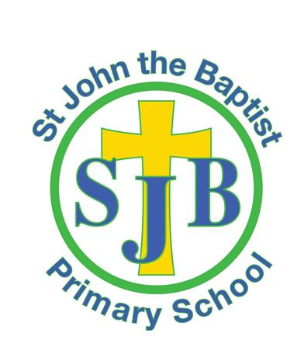
St John the Baptist
Primary School

Finaghy Road North, Belfast
BT11 9EH
Tel: 02890614546

OPEN MORNING
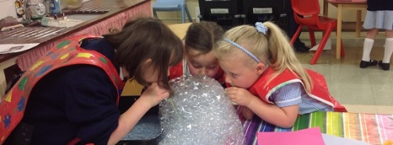
Wednesday 6th& Thursday 7th January 2015
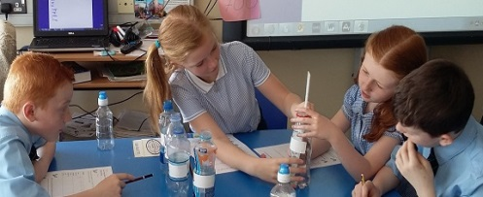
10.00am – 11:30am
Principal’s address 10am

Quotes from our recent Inspection Report found;
- During the inspection, almost all of the teaching observed was good or better.
- there are positive working relationships between the teachers, classroom assistants and children which engender an enthusiasm for learning;
- The teachers and the classroom assistants know the children and their families very well and demonstrate a commitment to the pastoral care and welfare of the children.
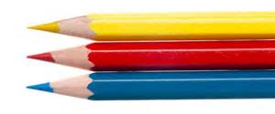
- The school’s performance data shows that almost all of the children make good progress in line with their ability or above expectation.

First school in Belfast to achieve Rights Respecting
award and youngest school involved in coding

Clubs and activities

Breakfast Club from 7:45am

